Incremental developmentmeans you develop your program in very small stages. This will make it easy for you to debug your code. As explained on the LibreTexts page for Think Python – Incremental Development: “As you write larger functions, you might find yourself spending more time debugging. To deal with increasingly complex programs, you might want to try a process called incremental development. The goal of incremental development is to avoid long debugging sessions by adding and testing only a small amount of code at a time.” (LibreTexts, 2021) Following this approach, i will develop the function for a hypotenuse.
Part 1.
Step 1:
I start with defining a function called hypotenuse(a, b) that lets me return a placeholder value of 0.0. This step is essential to verifythat it has a proper form. According to Think Python, 2016, Chapter 6: "Incremental development means starting with a simple version of the problem, and improving it step by step, testing at each step."
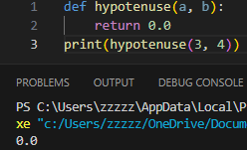
I have established the structure, and I am able to test the function to make sure that it does not contain any errors.
Step 2:
Next, I am able to alter the function in order to add up the squares of the two legs of a right triangle. This marks a critical step in applying the Pythagorean theorem.
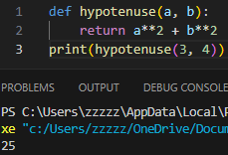
As described in Think Python, 2015, Chapter 1: "A program is a sequence of instructions that specifies how to perform a computation. The computation might be something mathematical, such as solving a system of equations or finding the roots of a polynomial." At this point, I have calculated the sum of the squares; however, I still haven’t finished with the calculation of the hypotenuse.
Step 3:
The square root function will then be used to find the value of the hypotenuse in order to complete this calculation. This calculation comes from the Pythagorean theorem.
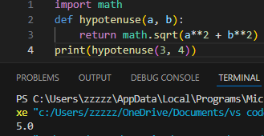
As noted in Think Python, 2015, Chapter 6: "A fruitful function is a function that returns a value. In this case, the hypotenuse function will return the length of the hypotenuse." At this stage, the function becomes productive since it evaluates and displays the value of the hypotenuse.
Step 4:
Further, I improve this function by adding a docstring that describes what this function does and how it does all of this calculations. This would make it easier for a person understanding this code since “We want to define a comment for what our function actually is supposed to do. The way that's done in Python is with something called a docstring” (KJD Electronics, 2017).
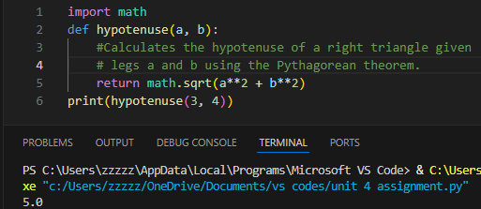
With the inclusion of a docstring, it becomes easier to understand this function.
Step 5:
Finally, we test this function with different inputs to check that it works well for different combinations of side lengths.
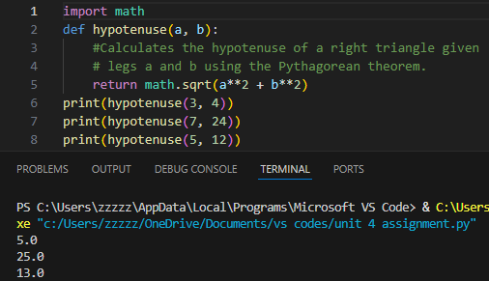
These tests verify that this function operates as it should with differently proportioned triangles.

Part 2.
In Part 2, I implemented a function for finding the area of a circle given its radius. I used incremental development for this part as well.
Step 1:
I will create a function that will find the area of a circle. This calculation involves a simple formula, which provides a practical function. To begin, I will create a structure for our function.
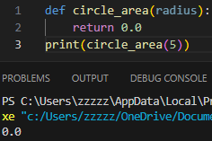
Everything begins with a definition of a function with a "placeholder value," which ensures that this function is defined as it should be.
Step 2:
Now, I will implement the calculation for finding the area of a circle with a formula Area=π*r**2
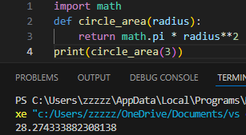
The function computes and returns the area of a circle, hence making it a fruitful function.
Step 3:
We add a docstring that explains what our function does and how it works.
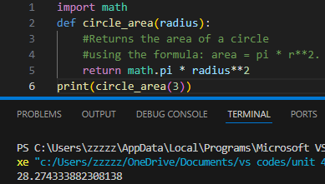
The docstring explains the purpose of, as well as a formula for, the calculation.
Step 4.
Finally, I will test this function for different values of the radius to make sure it operates in the intended manner.
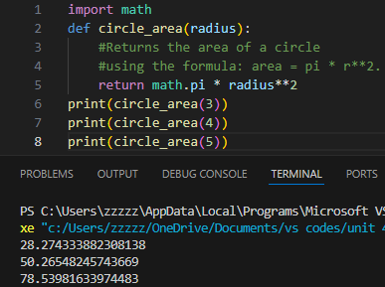
Now, the function has been tested, returning correct area for different values of the radius.

